DISHES AND THEIR ALLERGEN CONTENT – Clouds Restaurant Reviewed by: Anita Cheung Date:7/8/26

DISHES | 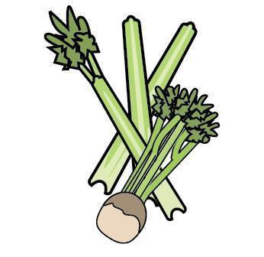 | 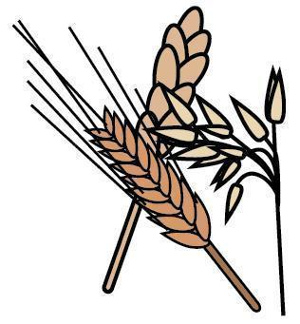 | 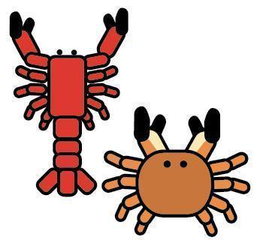 | 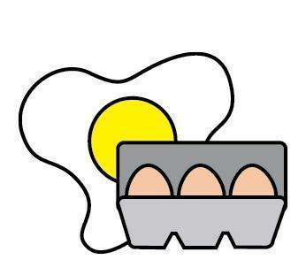 |  | 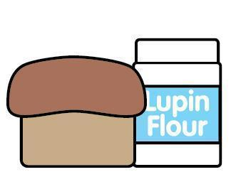 |  |  | 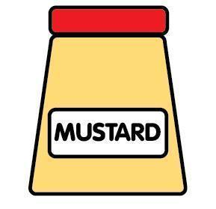 | 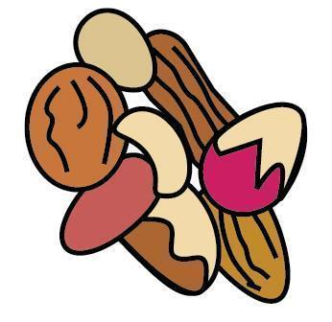 | 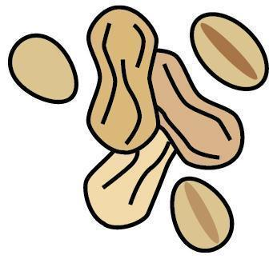 | 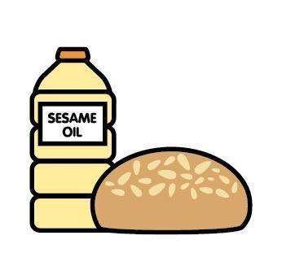 |  | 
 | Celery | Cereals containing gluten | Crustaceans | Eggs | Fish | Lupin | Milk | Mollusc | Mustard | Nuts | Peanuts | Sesame seeds | Soya | Sulphur Dioxide
Bao prawn toast |  | ✓  wheat | ✓ | ✓ |  |  |  |  |  |  |  | ✓ | ✓
Fortune Dumplings |  | ✓  wheat |  | ✓ |  |  |  |  |  |  |  | ✓ | ✓
GF Fortune Dumplings |  |  |  | ✓ |  |  |  |  |  |  |  | ✓ | ✓
Pork & Prawn Siu Mai |  | ✓  wheat | ✓ | ✓ | ✓ |  |  |  |  |  |  |  | ✓
Lamb Dumplings |  | ✓  wheat |  |  |  |  |  | ✓ |  |  |  |  | ✓
Pork Char Siu Baos |  | ✓  wheat |  | ✓ |  |  |  | ✓ |  |  |  | ✓ | ✓
Butternut bao |  | ✓  wheat |  |  |  |  |  |  |  |  |  |  | ✓
Mushroom Bao |  | ✓  wheat |  |  |  |  |  |  |  |  |  |  | ✓
DISHES
 | Celery | Cereals containing gluten | Crustaceans | Eggs | Fish | Lupin | Milk | Mollusc | Mustard | Nuts | Peanuts | Sesame seeds | Soya | Sulphur Dioxide
Butterbean Dumplings |  | ✓  wheat |  |  |  |  |  |  |  |  |  |  | ✓
Duck Wontons |  | ✓  wheat |  | ✓ |  |  |  |  |  |  |  |  | ✓
Beef Cheung Fun |  |  |  |  |  |  |  | ✓ |  |  |  | ✓ | ✓
Dough Stick Cheung Fun |  | ✓  wheat |  |  |  |  |  |  |  |  |  | ✓ | ✓
Pork Ham Sui Gok |  | ✓  wheat, barley |  |  |  |  |  | ✓ |  |  |  |  | ✓
Vegan Ham Sui Gok |  | ✓  wheat | * |  |  |  |  | * |  |  |  |  | ✓
Greens |  | ✓  wheat |  |  |  |  |  |  |  |  |  | ✓ | ✓
GF Greens |  |  |  |  |  |  |  |  |  |  |  | ✓ | ✓
Steamed Rice
DISHES
 | Celery | Cereals containing gluten | Crustaceans | Eggs | Fish | Lupin | Milk | Mollusc | Mustard | Nuts | Peanuts | Sesame seeds | Soya | Sulphur Dioxide
Deep Fried Chicken |  |  |  |  |  |  |  |  |  |  |  | ✓ | ✓
Ma Po Tofu |  | ✓  wheat |  |  |  |  |  |  |  |  |  | ✓ | ✓
Beef Pancakes |  | ✓  wheat |  |  |  |  |  |  |  |  |  |  | ✓
Pickled Mooli |  | ✓  Barley |  |  |  |  |  |  |  |  |  | ✓ |  | ✓
Cucumber Cloud ear salad |  | ✓  wheat |  |  |  |  |  |  |  |  |  | ✓ | ✓
Tofu Skin Rolls (served with GF CF dressing) |  |  | ✓ | ✓ | ✓ |  |  | ✓  Oyster in GF Cheung fun dressing |  |  |  |  | ✓
GF pork dumplings |  |  |  |  |  |  |  |  |  |  |  | ✓ | ✓
Deep fried oyster mushroom |  |  |  |  |  |  |  |  |  |  |  | ✓ | ✓
Pork dumplings (Ah Ma’s special) |  | ✓  wheat |  |  |  |  |  |  |  |  |  | ✓ | ✓
Veggie dumplings (Ah Ma’s special) |  | ✓  wheat |  |  |  |  |  |  |  | ✓  cashew |  | ✓ | ✓
DISHES
 | Celery | Cereals containing gluten | Crustaceans | Eggs | Fish | Lupin | Milk | Mollusc | Mustard | Nuts | Peanuts | Sesame seeds | Soya | Sulphur Dioxide
Lava bao |  | ✓  wheat |  | ✓ |  |  | ✓
Sesame puffs |  |  |  |  |  |  | ✓ |  |  | ✓  hazelnuts |  | ✓
Vegan sesame puffs |  |  |  |  |  |  |  |  |  |  | ✓ | ✓ | ✓
GF greens |  |  |  |  |  |  |  |  |  |  |  |  | ✓
Tamari sunflower seeds |  |  |  |  |  |  |  |  |  |  |  |  | ✓
HK French Toast |  | ✓  wheat |  | ✓ |  |  | ✓ |  |  | ✓  almonds | ¶
Deep fried Bao & condensed milk |  | ✓  wheat | * |  |  |  | ✓ | *
Roasted green tea ice cream |  |  |  |  |  |  | ✓
Matcha ice cream |  |  |  |  |  |  | ✓
Mango Coconut Saago
DISHES
 | Celery | Cereals containing gluten | Crustaceans | Eggs | Fish | Lupin | Milk | Mollusc | Mustard | Nuts | Peanuts | Sesame seeds | Soya | Sulphur Dioxide
Kombu dashi steamed egg |  |  |  | ✓
Kombu dashi steamed egg with trout roe |  |  |  | ✓ | ✓
Organic Tofu Salad |  | ✓  wheat |  |  |  |  |  |  |  |  |  | ✓ | ✓
Shredded Seitan Pancakes |  | ✓  wheat |  |  |  |  |  |  |  |  |  | ✓ | ✓
Lo Mein Noodles |  | ✓  wheat |  | ✓ |  |  |  |  |  |  |  | ✓ | ✓
Szechuan Noodles |  | ✓  wheat |  |  |  |  |  |  |  |  |  | ✓ | ✓
Sweet Soy Aubergine |  | ✓  wheat |  |  |  |  |  |  |  |  |  |  | ✓
Sticky Rice Parcels |  | ✓  wheat |  |  |  |  |  |  |  |  |  |  | ✓
Braised Tofu |  | ✓  wheat |  |  |  |  |  |  |  | ✓  gingko |  |  | ✓

