DISHES AND THEIR ALLERGEN CONTENT – Clouds Restaurant Reviewed by: Anita Cheung Date:12/03/26

DISHES | 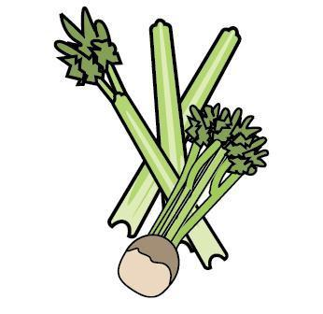 | 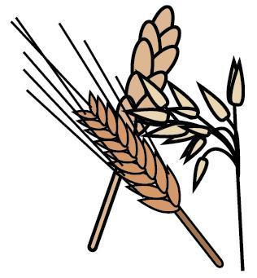 | 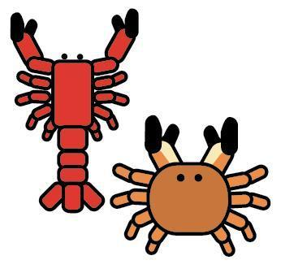 | 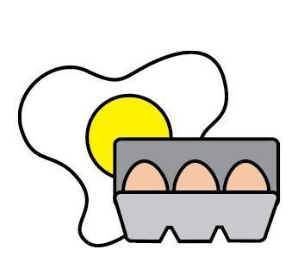 |  | 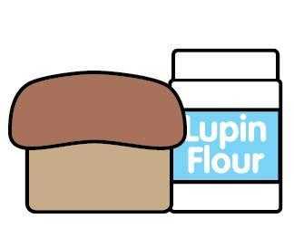 | 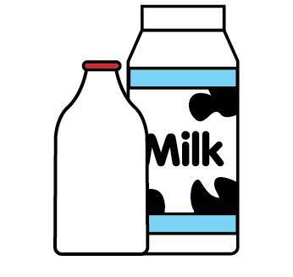 |  | 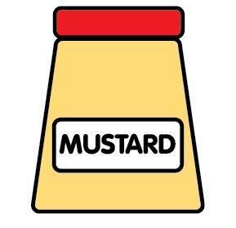 | 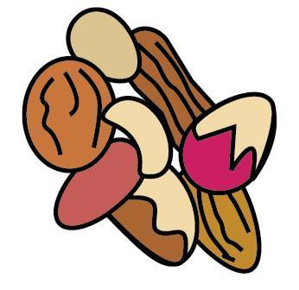 | 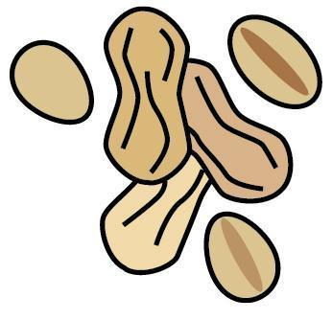 | 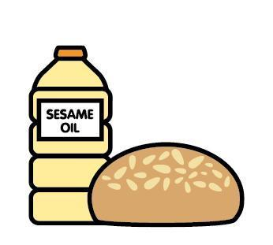 | 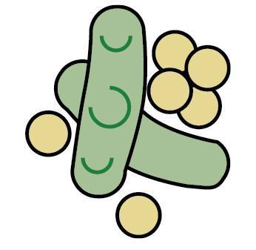 | 
 | Celery | Cereals containing gluten | Crustaceans | Eggs | Fish | Lupin | Milk | Mollusc | Mustard | Nuts | Peanuts | Sesame seeds | Soya | Sulphur Dioxide
bao prawn toast |  | ✓  wheat | ✓ | ✓ |  |  |  |  |  |  |  | ✓ | ✓
Crab & Water Chesnut Crystal Dumplings |  | ✓  wheat | ✓
Pork & Prawn Siu Mai |  | ✓  wheat |  | ✓ | ✓ |  |  |  |  |  |  |  | ✓
Butternut Siu Mai |  | ✓  Wheat |  | ✓ |  |  |  |  |  |  |  |  | ✓
Chestnut mushroom dumplings |  | ✓  wheat
GF chestnut mushroom dumplings
Pork Char Siu Baos |  | ✓  wheat |  |  |  |  |  | ✓ |  |  |  | ✓ | ✓
Butternut bao |  | ✓  wheat |  |  |  |  |  |  |  |  |  |  | ✓
Mushroom Bao |  | ✓  wheat |  |  | ✓  In worcestershire cream |  |  |  |  |  |  |  | ✓
DISHES
 | Celery | Cereals containing gluten | Crustaceans | Eggs | Fish | Lupin | Milk | Mollusc | Mustard | Nuts | Peanuts | Sesame seeds | Soya | Sulphur Dioxide
Mushroom Bao (vegan) |  | ✓  wheat |  |  |  |  |  |  |  |  |  |  | ✓
Butterbean Dumplings |  | ✓  wheat |  |  |  |  |  |  |  |  |  |  | ✓
Duck Wontons |  | ✓  wheat |  | ✓ |  |  |  |  |  |  |  | ✓ | ✓
Beef Cheung Fun |  |  |  |  |  |  |  | ✓ |  |  |  | ✓ | ✓
Dough Stick Cheung Fun |  | ✓  wheat |  |  |  |  |  |  |  |  |  | ✓ | ✓
Pork Ham Sui Gok |  | ✓  wheat, barley |  |  |  |  |  | ✓ |  |  |  |  | ✓
Vegan Ham Sui Gok |  | ✓  wheat | * |  |  |  |  | * |  |  |  |  | ✓
Greens |  | ✓  wheat |  |  |  |  |  |  |  |  |  |  | ✓
GF Greens |  |  |  |  |  |  |  |  |  |  |  |  | ✓
Steamed Rice
DISHES
 | Celery | Cereals containing gluten | Crustaceans | Eggs | Fish | Lupin | Milk | Mollusc | Mustard | Nuts | Peanuts | Sesame seeds | Soya | Sulphur Dioxide
Deep Fried Chicken |  |  |  |  |  |  |  |  |  |  |  | ✓ | ✓
Poached Chicken |  | ✓  wheat |  |  |  |  |  |  |  |  |  | ✓ | ✓
GF Poached Chicken |  |  |  |  |  |  |  |  |  |  |  | ✓ | ✓
Ma Po Tofu |  | ✓  wheat |  |  |  |  |  |  |  |  |  | ✓ | ✓
Beef Pancakes |  | ✓  wheat |  |  |  |  |  |  |  |  |  |  | ✓
Pickled Mooli |  | ✓  wheat |  |  |  |  |  |  |  |  |  | ✓ |  | ✓
Tea Egg |  | ✓  wheat |  |  |  |  |  |  |  |  |  |  | ✓
Siu Choy Pickle |  |  |  |  |  |  |  |  |  |  |  | ✓
Tofu Skin Rolls |  | ✓  Barley in Worcestershire sauce | ✓ | ✓ | ✓ |  |  |  |  |  |  |  | ✓
GF pork dumplings |  |  |  |  |  |  |  |  |  |  |  | ✓ | ✓
DISHES
 | Celery | Cereals containing gluten | Crustaceans | Eggs | Fish | Lupin | Milk | Mollusc | Mustard | Nuts | Peanuts | Sesame seeds | Soya | Sulphur Dioxide
Pork dumplings (Ah Ma’s special) |  | ✓  wheat |  |  |  |  |  |  |  |  |  | ✓ | ✓
Veggie dumplings (Ah Ma’s special) |  | ✓  wheat |  |  |  |  |  |  |  | ✓  cashew |  | ✓ | ✓
Lava bao |  | ✓  wheat |  | ✓ |  |  | ✓
Sesame puffs |  |  |  |  |  |  | ✓ |  |  |  | ✓ | ✓
Vegan sesame puffs |  |  |  |  |  |  |  |  |  |  | ✓ | ✓ | ✓
GF greens |  |  |  |  |  |  |  |  |  |  |  |  | ✓
Tamari sunflower seeds |  |  |  |  |  |  |  |  |  |  |  |  | ✓
HK French Toast |  | ✓  wheat |  | ✓ |  |  | ✓ |  |  | ✓  almonds
Deep fried Bao & condensed milk |  | ✓  wheat | * |  |  |  | ✓ | *
Broccoli, pak choi, pea salad |  |  |  |  |  |  |  |  | ✓ |  |  | ✓ | ✓
DISHES
 | Celery | Cereals containing gluten | Crustaceans | Eggs | Fish | Lupin | Milk | Mollusc | Mustard | Nuts | Peanuts | Sesame seeds | Soya | Sulphur Dioxide
Kombu dashi steamed egg |  |  |  | ✓
Kombu dashi steamed egg with trout roe |  |  |  | ✓ | ✓

